Finishing Wood
Applying a finish is essential to protect the wood's surface. Without a finish, wood can dry, crack and deteriorate or – if exposed to moisture – swell so that things like drawers and doors no longer work. A good finish prevents swelling and cracking, protects against stains and even makes the wood look better by bringing out its natural lines. Once a wood surface is prepared and stained, the finish is applied. It usually consists of several coats of wax, shellac, drying oil, lacquer, varnish, or paint, and each coat is typically followed by sanding.
Some finishes contain chemicals that can be dangerous if used without proper safety precautions. Some finishes emit hazardous fumes, so work outdoors or in a well-ventilated area with a fan for circulation. Never work near an open flame.
All finishes can be divided into two categories:
- penetrating finishes (those that dry inside the wood) Penetrating finishes are easier to apply and leave a more natural look.
- surface finishes (those that dry on the surface of the wood). Surface finishes are more durable but don't look as natural.
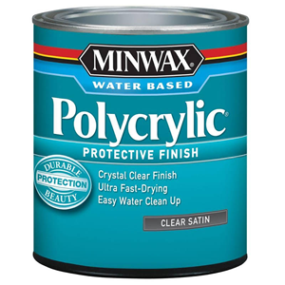
We are using polycrylic it is good for indoor uses.
Preparation and use:
- The surface must be clean (free of oil or dust), smooth and dry.
- Stir well. DO NOT SHAKE
- Apply a thin coat
- Let dry at least 2 hours
- Sand gently if adding another coat later on.
Clean up with soap and water
Questions:
- What can happen to unfinished wood? __________________________________________
- What is a safety procedure for finishing wood? ______________________________
- Which kind of finish is easy to apply and makes the wood look natural? _________________
- Which kind of finish is more durable but looks less natural? _____________________
- What do you need to do to the wood BEFORE you finish it? _______________________________________
- Should you shake the can to get it well mixed before you use it? _______
- How do you clean up any spilled polycrylic protective finish? ______________________
- How long does the polycrylic protective finish need to dry? _______________
- Should you put the coating on with a thick coat or a thin coat? ______________

